VOC Screening Survey of the PES Refinery Perimeter

November 19, 2019

Julian Grauer, Consulting Engineer

**Introduction.**

A screening survey was conducted at various residential and non-residential sites adjacent to the PES Philadelphia Refinery to estimate the concentration of volatile organic compounds (VOCs). Since this survey is based on field measurements it is only intended as screening procedure whose results may be used to guide other sample collection activities and advanced techniques such as GC/MS analysis.

At test is the hypothesis that some fraction of the VOCs emitted by supply stocks, petrochemical processes and product storage escape the boundaries of the PES refinery through groundwater, fugitive emissions or runoff and are retained by soils adjacent to the refinery

A head space analysis was performed on surface soils at 13 sites following the procedures outlined in the EPA Method 3815 (SCREENING SOLID SAMPLES FOR VOLATILE ORGANICS)

**The Setting.**

The PES Philadelphia refinery occupies a 1,295-acre site located in south west Philadelphia and is south east of the fall line. The southernmost point is near the confluence of the Schuylkill and Delaware Rivers and extends north about 3,300 meters to a parallel with Wolf St. The widest contiguous portion of the property is about 1,700 meters measured east/west.

The area occupied by the PES has a long history of oil refining. In the late nineteenth century, a refinery cluster emerged on both sides of the Schuylkill making the current PES site the oldest continuously operating petroleum facility in the world.

**Materials and Methods.**

The testing procedure is an equilibrium headspace analysis. Thirteen samples were collected from undisturbed disturbed soil at depths ranging from 1 to 12 inches. All measurements were performed on- site as each sample was collected. Using a stainless-steel scoop, about 400 ml of sample soil was placed in an 800-ml glass jar, sealed with aluminum foil, covered with a metal lid and vigorously shaken for about 20 seconds. The soil was allowed to equilibrate for 10 minutes after which the sampling tube from a MiniRae 3000 model GP 11012 was pushed through a small hole in metal cover to penetrate the aluminum foil. The maximum VOC reading obtained in this process was recorded. Prior to soil testing the MiniRae 3000 was calibrated with 100 PPM Isobutylene.

**Survey Sites.**

Thirteen survey sites were selected for sampling in order to assess VOCs in both residential areas and areas near the perimeter of the refinery. Samples 6, 7 and 8 are near housing developments and samples 1, 2, 5, 9 and 10 are sites that are close to the PES boundary line. Samples 3,4 and 12 are on the southern boundary of the refinery which is a primary direction of flow for ground water. The remaining sites, 11 and 13, were used as controls.

**The PES Refinery Survey Area**

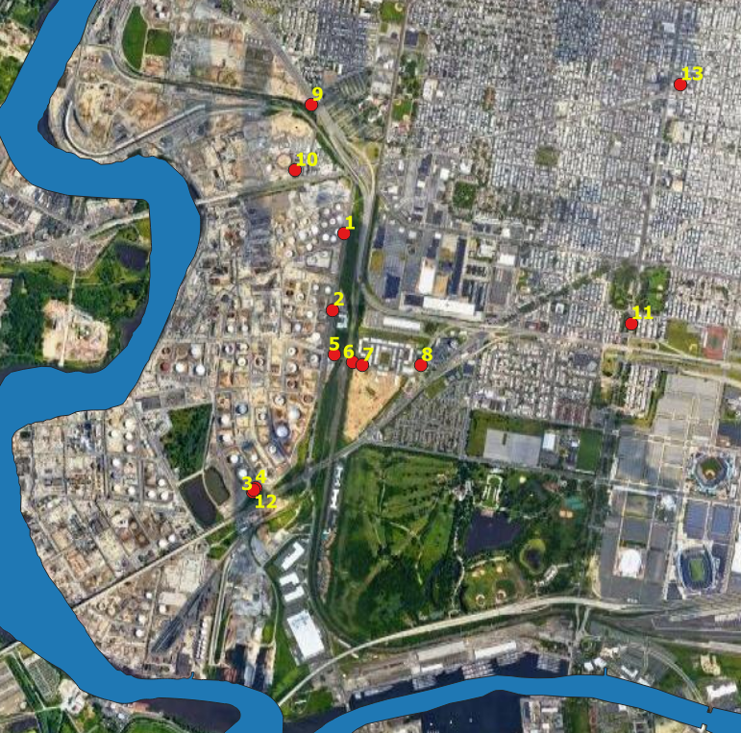

**Results**

The survey revealed one area of slightly elevated VOCs while all other sites had none or very low levels. In general, the soil adjacent to the refinery has VOC levels similar to soil samples collected at distance from the refinery.



At 3 of the survey sites the surface soil was removed exposing a tan, pale-brown clay at depths from 5 to 12 inches. The clay layer was too dense to allow deeper excavation with hand tools (see next page for picture.)

**Discussion**

The survey results indicate that runoff and fugative emissions are not pollution pathways for VOCs in the areas that were surveyed. Ground water, however, can also be pollution pathway especialy since the water table near the refinery is high and under these conditions the light non-aquis phase liquids (LNAPL) floating close to surface may volitize and travel up through the soil.

Ground water can become contaminated as a result of leaks from storage tanks, values, flanges and underground piping. PES well gauge reports in 2012 indicate that a significant amount of leakage from the refinery has reached the water table. About 1/3 of the 150 wells that are mainly located in AOI-1 showed the presence of LNAPL’s floating near the top of the water table which is found at a depth of 15 to 26 feet below the surface. For 16 of these wells, the depth of the LNAPLs ranged from ½ inch to 4 inches.

As contaminents reach the water table and even deeper layers they spread out and in the case of the PES refinery they would appear as an elliptical shaped plume with the long axis pointing South and South East extending for 1 or 2 kilometers.

For serveral years PES has been extracting ground water and seperating the pollutants from the pollution plume. A 2014 report stated that 246,853 gallons of LNAPL had been extracted from water wells. It is, therefore, possible that the PES “pump and treat” strategy has reduced the size of the pollution plume and this could explain the absence of VOC’s in the surface soil. Another interpertation of the data, however, is that layers of clay have isolated the surface soil from polluntants located at lower levels in the ground.

**The Clay Layer**

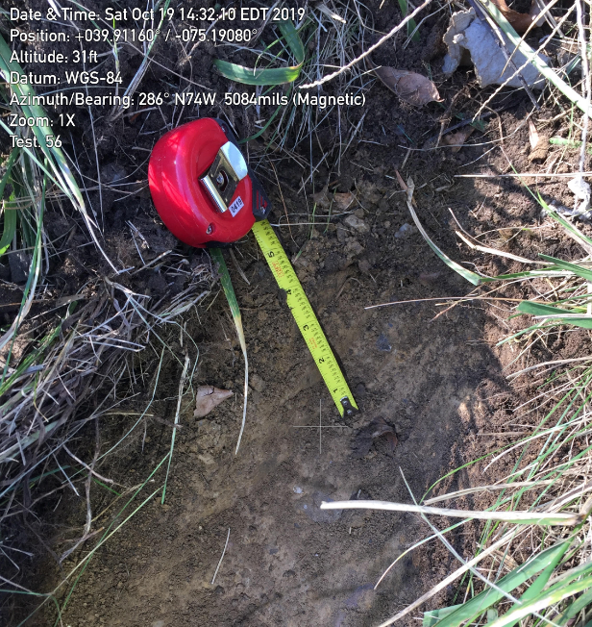

At three of the VOC survey sites an attempt was made to excavate about a foot of soil in order to test subsurface conditions and in each case a tough layer of clay was encountered within a few inches of the surface. Clay has the capacity to encapsulate and absorb refinery contaminants which could explain the absence of VOC’s at the soil surface, assuming that the clay unit is wide-spread or at least present in the survey area.

Data from the Monitoring Well Logs and Subsurface Boring Logs provided by Aquaterra are summarized in the following table:

|  |  |  |  |  |
| --- | --- | --- | --- | --- |
| Number | Depth of | Number of Wells | Average Depth of the Clay | Number of Wells Not |
| of Wells | Well | Encountering a Clay Layer | layer from the Surface | Encountering a Clay Layer |
| 25 | 0 to 2 feet | 0 | N/A | 25 |
| 21 | >2 to 20 feet | 12 | 11.2 | 7 |
| 8 | > 20 to 30 feet | 4 | 20.5 | 4 |
| 1 | 53 | 1 | 15 | N/A |
| 1 | 76 | 1 | 20 | N/A |

Sampling to a depth of 2 feet using a hand auger did not reveal any clay near the surface as was the case with the VOC survey although the two deepest wells found a substantial clay layer at 15 and 20 feet respectively that extended down through the full depth of the borehole. The extent of the clay at the PES refinery is not clear from this data since four out of a total of 8 wells that extended 30 feet did not encounter a clay layer. Conclusions about the spread of contaminants from the PES will have to wait until additional data becomes. available.